**FLIGHT BOOKING SYSTEM**

**POC**  
**Low Level Design (LLD)**



Date:00/00/2022

Current Document Version: [*1.0*]

DOCUMENT APPROVAL

**Approvers of this document**

|  |  |  |  |  |
| --- | --- | --- | --- | --- |
| **Name** | **Department** | **Role** | **Signature** | **Date** |
|  |  |  |  |  |
|  |  |  |  |  |
|  |  |  |  |  |

**Document Change History**

|  |  |  |  |
| --- | --- | --- | --- |
| **Document Version #** | **Author** | **Date** | **Description** |
| 1.0 | Muraharirao Nikhileswara Sri Venkat | 24/07/2022 | Flight Booking System LLD |
|  |  |  |  |
|  |  |  |  |

**Contents**

1.0 Document Purpose 5

2.0 Intended Audience 5

3.0 Project Background, Objective(s) 5

3.1 Project Background 5

3.2 Project Objective 5

4.0 Design Pattern 5

5.0 Solution Diagram 6

6.0 Architecture Diagram 6

7.0 Flow Diagram 7

8.0 Use case Diagram 8

9.0 Class Diagram 9

10.0 E-R Diagram 10

11.0 User Requirements 11

11.1 Hardware 11

11.2 Software 11

12.0 Developer Requirements 11

12.1 Hardware 11

12.2 Software 11

12.3 Technology 12

13.0 Solution Steps 12

14.0 Classes/function 14

15.0 Data Model 15

16.0 API Canvas 16

17.0 HTTP Status Code 16

# Document Purpose

This document describes the solution architecture for Flight Booking System.

# Intended Audience

This document is intended as a reference for the following roles and stakeholders who are interested in the Flight Booking System technical architecture.

|  |  |
| --- | --- |
| Role | Nature of Engagement in WB Classics Portal Technical Architecture |
| Product Owners/SME | Key stakeholder to ensure that the architecture is aligned with business goals. |
| Business Analysts | Business analysts are one of the stakeholders who are informed with the key architectural decisions. |
| Enterprise Architects | Platform Architecture is aligned to business goals and architecture, architectural guidelines. |
| Solution Architects | To ensure solution design and architecture is aligned to business requirements, architectural guidelines. |
| Developers | Use Technical Architecture Document as the guiding document for detail design and implantation approach to align with Flight Booking System microservice. |
| End User | An end user can search flights, check flight fares, book and cancel flights. |

# Project Background, Objective(s)

## Project Background

Flight Booking System leads to perform flight bookings where one can register themselves and perform various operations.

## Project Objective

Flight Booking System will perform various operations like,

**User Option** - Home, Login, Search Flight, Book Flight, Cancel Booking, View Booking, Change Password, Logout.

**Admin Option** - Login, Check In, Add Flights data, Edit Flights data, delete Flights data, Add, Edit Customer data, Cancel Reservation.

# Design Pattern

|  |  |  |
| --- | --- | --- |
| **#** | **Name** | **Description** |
| 1 | ANGULAR | Angular is used for the frontend and designing of the application. |
| 2 | API | API is used as connection between frontend and database. |
| 3 | SQL SERVER | SQL server is used to store data to the database |

# Solution Diagram

# 

# Architecture Diagram

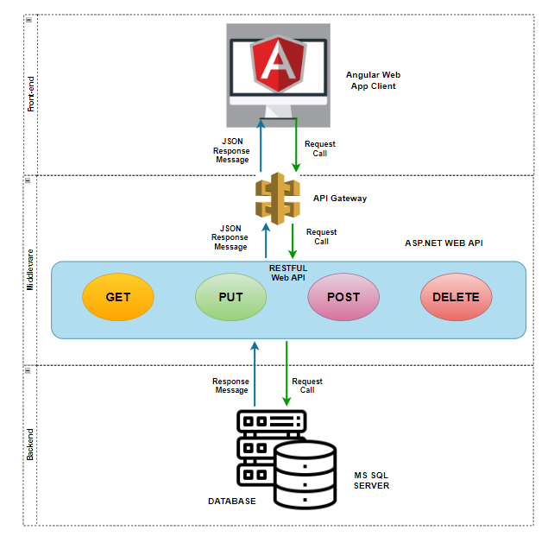

# Flow Diagram

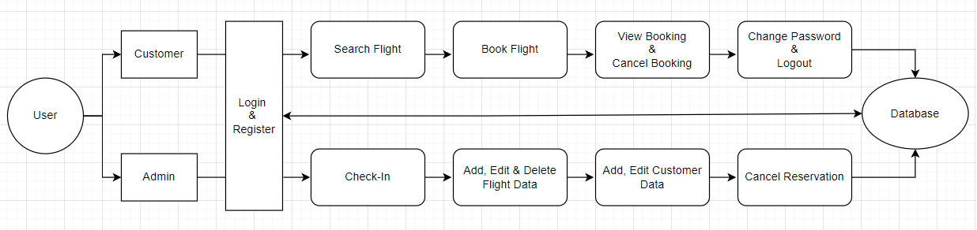

# 8.0 Use case Diagram

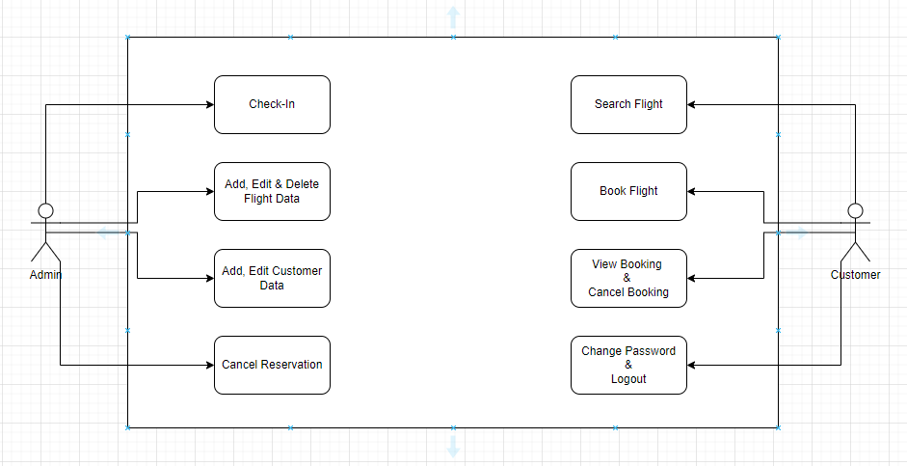**9.0 Class Diagram**

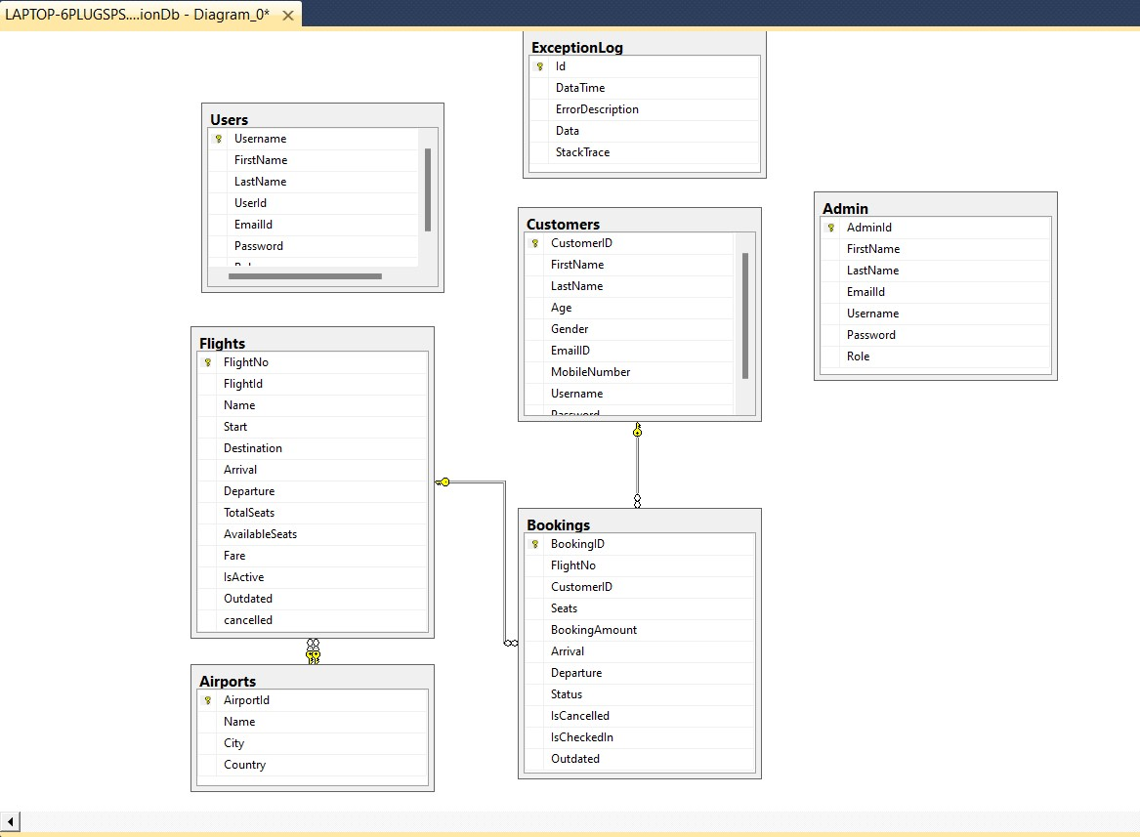

# 10.0 E-R Diagram

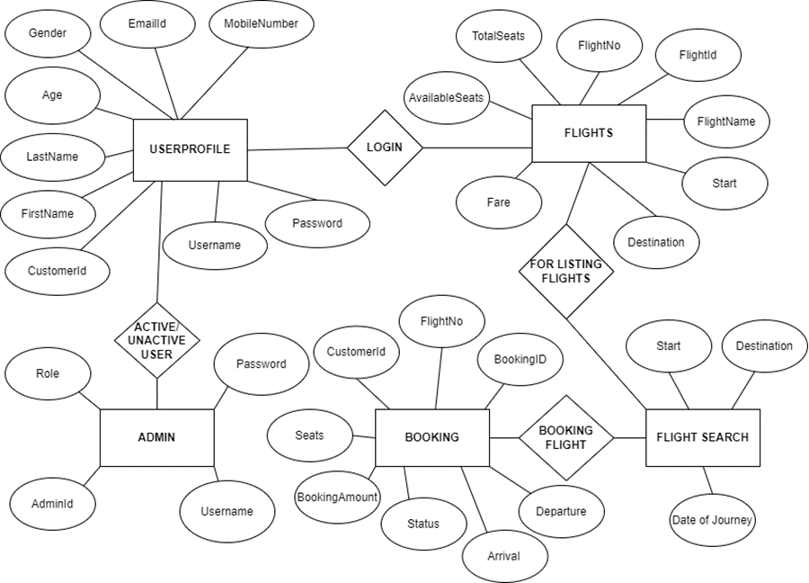**11.0 User Requirements**

**11.1 Hardware**

• Processor: Minimum 1.8 GHz. Recommended 2GHz or more

• Ethernet connection (LAN) OR a wireless adapter (Wi-Fi)

• Hard Drive: Minimum 100 GB; Recommended 500GB or more

• Memory (RAM): Minimum 4 GB; Recommended 8 GB or above

• OS: Windows

**11.2 Software**

• Any Latest Browsers

**12.0 Developer Requirements**

**12.1 Hardware**

• Processor: Minimum 1.8 GHz. Recommended 2GHz or more

• Ethernet connection (LAN) OR a wireless adapter (Wi-Fi)

• Hard Drive: Minimum 100 GB; Recommended 500GB or more

# • Memory (RAM): Minimum 4 GB; Recommended 8 GB or above

# • OS: Windows

# 12.2 Software

# • Visual Studio 2022

# •SQL Server Management Studio 2014 (SSMS)

# • Node JS, Angular

# 12.3 Technology

# • ASP.NET CORE 6.0 for back-end

# •SQL for the database operations

# • Angular for front-end

# 13.0 Solution Steps

1. **Customer Registration:**
2. The user will select their role as a customer or Admin.
3. Customer will enter the required details such as Firstname, Lastname, Email, Phone Number, Gender, Age, Username, Password and click submit button to register.
4. The API call reaches respective controllers (Customer registration controller)
5. The input validation will have the Customer as argument to perform the validation,
6. If validation fails, then it will return the error code and error description with status code
7. If validation is successful, then the Customer details are stored in the database and success code is sent.
8. Success JSON response and HTTP status code 200 with corresponding success message.
9. **Customer and Admin Login:**
10. If customer or admin wants to login into their account then they have to enter Username and Password into the fields and click ‘Login’.
11. Admin can able to make customers account active/inactive and they can able to Check In, Add Flights data, Edit Flights data, delete Flights data, Add, Edit Customer data, Cancel Reservation and change password.
12. Customers can do the following options like Home, Login, Search Flight, Book Flight, Cancel Booking, View Booking, Change Password, Logout
13. The API call reaches the respective methods and controllers to make the changes or to fetch the data.
14. Then it will get updated in the database.
15. Success response code is returned.
16. Success JSON response and HTTP status code 200 with corresponding success message.
17. **Search a Flight:**
18. If Customer wants to search a flight, they have to enter FROM location, TO location, Date of Travel and click ‘Search’ button.
19. Now the API call reaches the controller and retrieves the data from database.
20. The list with all the flights are returned to the controller.
21. The controller returns the JSON response to API.
22. The available flights get displayed to the customers.
23. Success JSON response and HTTP status code 200 with corresponding success message.
24. **Flight Booking:**
25. Customer then chooses the required flight he/she wants and click the book option.
26. After, the Customer can enter his/her details, and create a booking by clicking on the CONFIRM button.
27. If booking is successful, the next confirmation screen is displayed with a booking reference number or booking id.
28. **Cancel a booking:**
29. If a booking to be cancelled, customer or admin must enter their Booking ID as input and click the ‘Cancel’ button.
30. If the Booking is present, it will delete from the database, it sends a response body with HTTP Success response code 200 else sends the not found response code 404.
31. The success JSON response and HTTP status code 200 with corresponding success message to the API gateway which will send to web app. Web app will displays Success message on the view.
32. **View a booking:**
33. If a booking to be viewed, user or admin must enter their Booking ID as input and click the ‘View’ button.
34. If the data is successfully fetched from the database, it sends the response body with the JSON data and HTTP Success response code 200 else sends the response code 404 not found
35. The success JSON response and HTTP status code 200 with corresponding success message to the API gateway. The web app will display the list of all the flights as searched with a ticket booking button ‘Book’.
36. **Change the password:**
37. If user or admin want to change the password, user or admin must enter the Username, old password and new password as input and click the ‘Submit’ button.
38. If the Username and the password are matched with the one on the database then it will change the password and sends the success code 200 else sends error code 400.
39. The success JSON response and HTTP status code 200 with corresponding success message to the API gateway which will send to web app. Web app will displays Success message on the view.
40. **Updating Check-In status:**
41. If the user wants to check in into a flight, user or admin must enter their Booking ID as input and click the ‘Check In’ button.
42. User inputs are validated by the angular web application:
43. If validation fails, then it will return the error code and error description with status code 400
44. If validation is successful, Call reaches the Web API gateway and it calls the API/controller ‘Booking’ and also the method ‘CheckInAFlight()’.
45. If check-in is successful, it displays the confirmation message along with the booked seat number.

# 14.0 Classes/function

|  |  |  |
| --- | --- | --- |
| **#** | **Class** | **Description** |
| 1 | Customers.cs | Model holds the customers schema details |
| 2 | Flights.cs | Model holds the Flights schema details |
| 3 | Bookings.cs | Model holds the bookings schema details |
| 4 | Admin.cs | Model holds the admin schema details |
| 5 | Airports.cs | Model holds the airports schema details |
| 6 | Login.cs | Model holds the Login details schema details |
| 7 | CustomersController.cs | Controller Model holds the customers schema details |
| 8 | FlightsController.cs | Controller model holds the Flights schema details |
| 9 | BookingsController.cs | Controller model holds the bookings schema details |
| 10 | AdminController.cs | Controller model holds the admin schema details |
| 11 | AirportsController.cs | Controller model holds the airports schema details |
| 12 | LoginController.cs | Controller model holds the Login details schema details |
| 13 | DBContext.cs | Model holds the Db context schema details |
| 14 | Repository.cs | Repository holds the repository schema details of all the fields |
| 15 | Interface.cs | Interface holds the interface schema details of all the fields |
| 16 | Services.cs | Service holds the service schema details of all the fields |

# 15.0 Data Model

|  |  |  |
| --- | --- | --- |
| **Constraints** | **Columns** | **Data Types** |
| **Users** | | |
|  | Username | Varchar(15) |
|  | FirstName | Varchar(50) |
|  | LastName | Varchar(50) |
|  | UserId | int |
|  | EmailId | Varchar(25) |
|  | Password | Varchar(15) |
|  | Role | Varchar(16) |
| **Admin** | | |
| PK | Admin ID | Varchar(10) |
|  | Name | Varchar(100) |
|  | Role | Varchar(5) |
| **Flights** | | |
| PK | Flight No | int |
|  | Flight ID | Varchar(10) |
|  | Name | Varchar(10) |
| FK | Start | Varchar(10) |
| FK | Destination | Varchar(10) |
|  | Arrival | DateTime |
|  | Departure | DateTime |
|  | Seats | int |
|  | Base price | Decimal |
| **Customers** | | |
| PK | Customer ID | int |
|  | Customer Name | Varchar(100) |
|  | Email ID | Varchar(50) |
|  | Mobile Number | Varchar(10) |
|  | Gender | Varchar(5) |
|  | Login ID | Varchar(15) |
|  | Password | Varchar(16) |
| **Bookings** | | |
| PK | Booking ID | Varchar(10) |
| FK | Customer ID | int |
| FK | Flight No | int |
|  | Booking Amount | Decimal |
|  | Arrival date | DateTime |
|  | Checked In | Varchar(10) |
|  | Seats | int |
|  |  |  |

# 16.0 API Canvas

|  |  |  |  |  |  |  |
| --- | --- | --- | --- | --- | --- | --- |
| **S.NO** | **Micro Service** | **Path** | **Verb** | **API Description** | **Role** | **Auth** |
| 1 | Flight Booking System | /Login | GET | To login the user or admin account | No | True |
| 2 | Flight Booking System | /Customers | GET | To get customer details | No | True |
| 3 | Flight Booking System | /Customers | POST | To register a new customer | No | True |
| 4 | Flight Booking System | /Customers/id | GET | To get customers details by customer id | No | True |
| 5 | Flight Booking System | /Customers/id | PUT | To record edited customer details by id | No | True |
| 6 | Flight Booking System | /Customers/id | DELETE | To delete customers details by customer id | No | True |
| 7 | Flight Booking System | /Flights/start/dest/doj | GET | To search the flights on start place, destination and date of journey | No | True |
| 8 | Flight Booking System | /Flights/id | GET | To search the flights on a date and list all the flights | No | True |
| 9 | Flight Booking System | /Flights/Flightno | GET | To get the list of flights by flight number | Admin | True |
| 10 | Flight Booking System | /Flights/Flightno | PUT | To record edited flight data by flight number | Admin | True |
| 11 | Flight Booking System | /Flights/Flightno | DELETE | To delete flight data by flight number | Admin | True |
| 12 | Flight Booking System | /Booking/id | POST | To book a flight on a particular date | No | True |
| 13 | Flight Booking System | /Booking/id | GET | To all the view the bookings | Admin | True |
| 14 | Flight Booking System | /Booking/id | DELETE | To cancel a booking by its booking ID | No | True |
| 15 | Flight Booking System | /Booking/id | PUT | To record the checking Ins by the admin | Admin | True |
| 16 | Flight Booking System | /Airports | GET | To get the available airports | Admin | True |
| 17 | Flight Booking System | /Airports | POST | To add airport data | Admin | True |
| 18 | Flight Booking System | /Airports/id | GET | To get the available airports by id | Admin | True |
| 19 | Flight Booking System | /Airport/id | PUT | To modify the airport data by id | Admin | True |

# 17.0 HTTP Status Code

200 - Request succeeded

400 – Inputs are invalid

401--Unauthorized

404 – Data not found

502 – Bad gateway

501--Not implemented